AIM: To implement the AdaBoost Classification Algorithm using Python to predict students' results (Pass or Fail) based on hours studied, attendance, and assignments, and evaluate the model using accuracy, confusion matrix, classification report, and a feature-importance graph.

ALGORITHM:
1. Start the program.
2. Import the required libraries: Pandas, Matplotlib, and Scikit-learn.
3. Load the student dataset from data.csv.
4. Remove extra spaces from the column names.
5. Select Hours studied, Attendance, and Assignment as input features.
6. Select Result as the target variable.
7. Split the dataset into training and testing sets using an 80:20 ratio.
8. Create an AdaBoost Classifier model with 50 estimators.
9. Train the model using the training dataset.
10. Predict the students' results using the testing dataset.
11.Calculate and display the accuracy score.
12.Display the confusion matrix and classification report.
13.Calculate feature importance and plot the bar graph.
14.Stop the program.

OUTPUT:
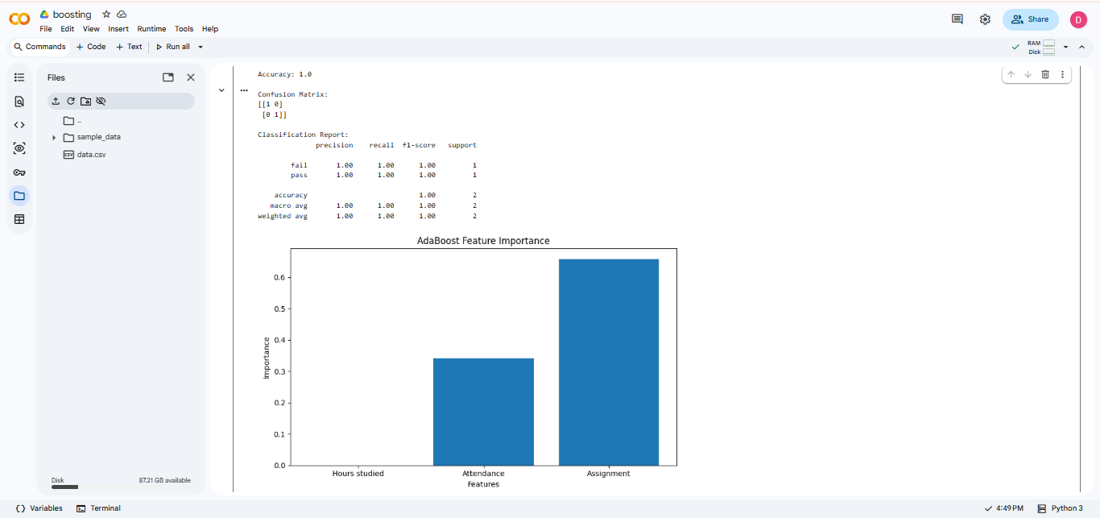

RESULT: Thus, the AdaBoost classification algorithm is implemented successfully to predict student results and evaluate the model's performance.

